Q1. 2015 Quiz

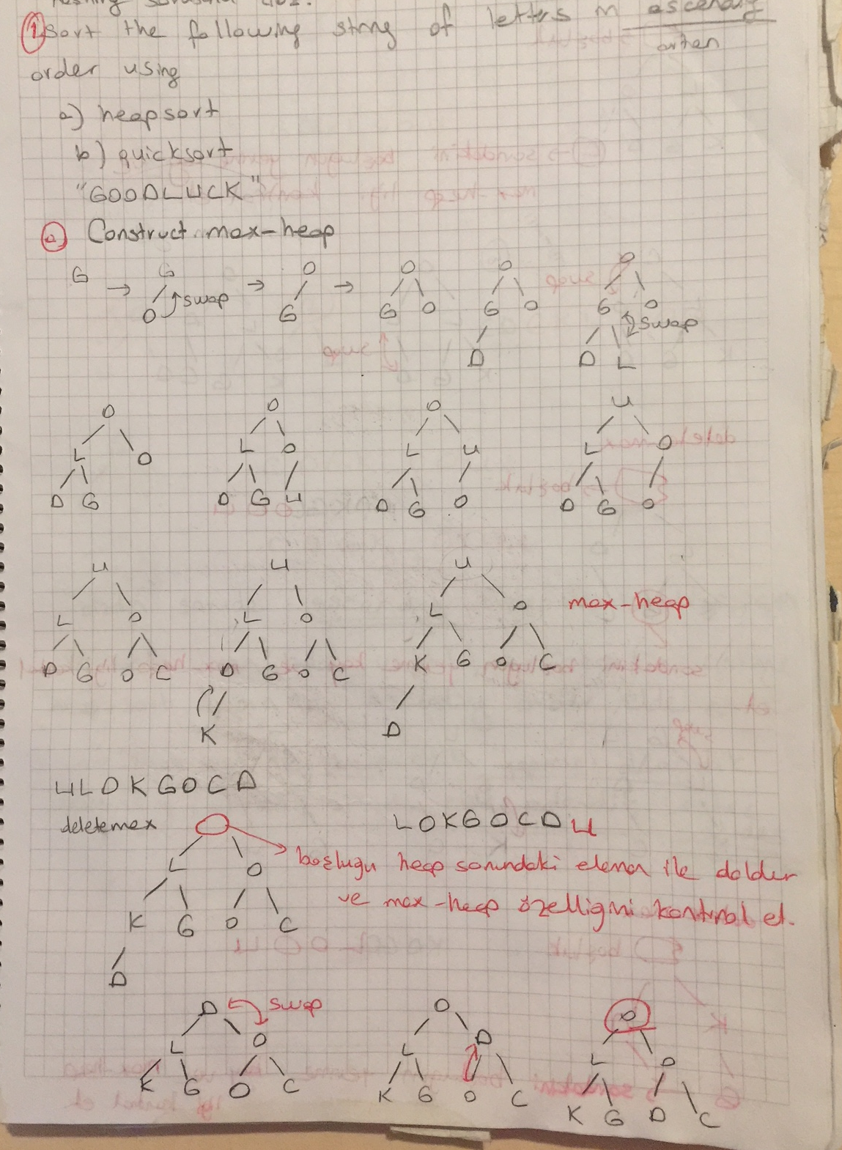

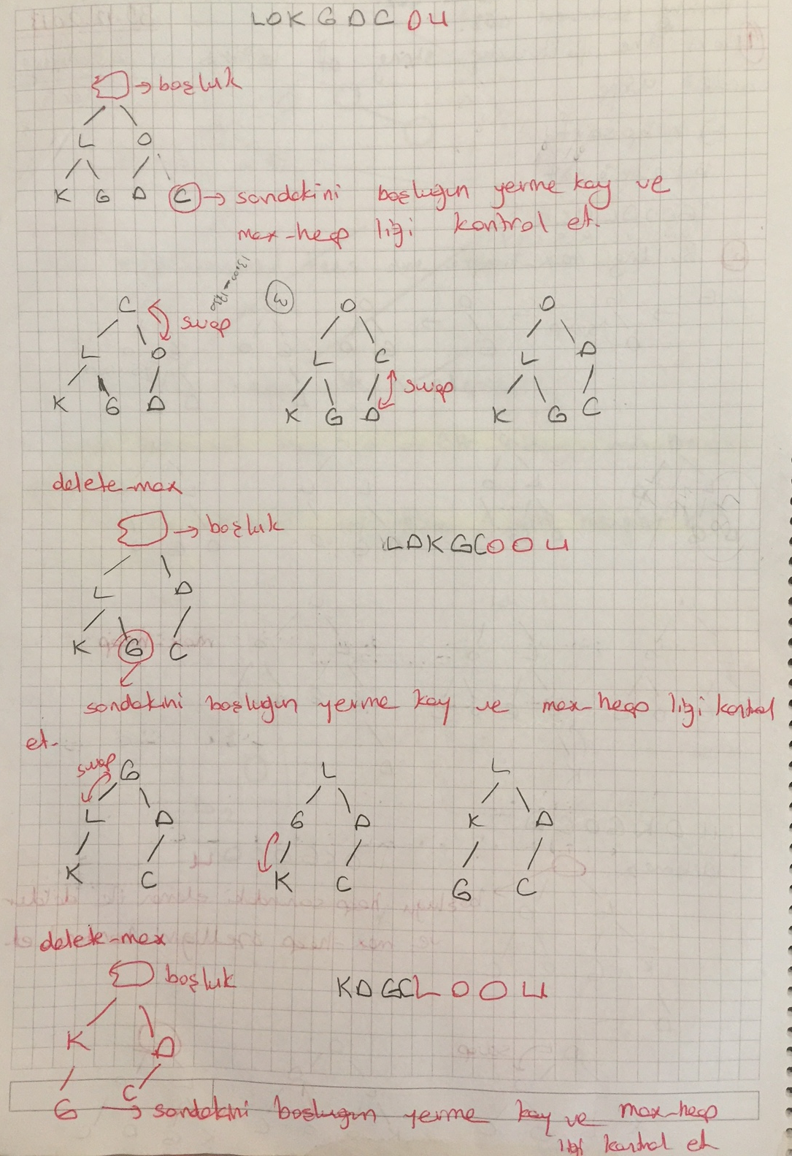

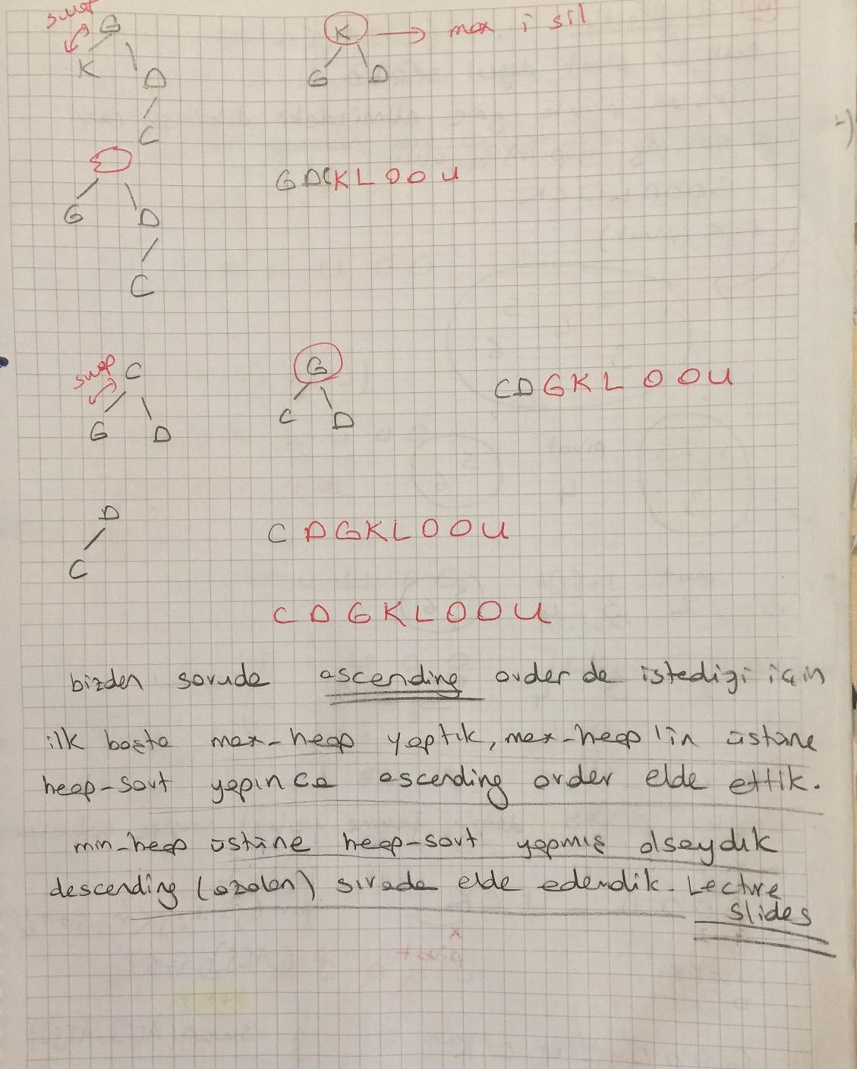

b) Quicksort

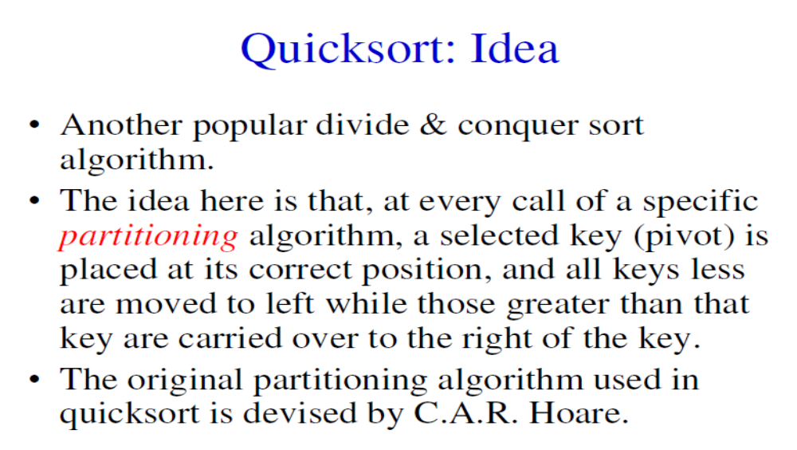

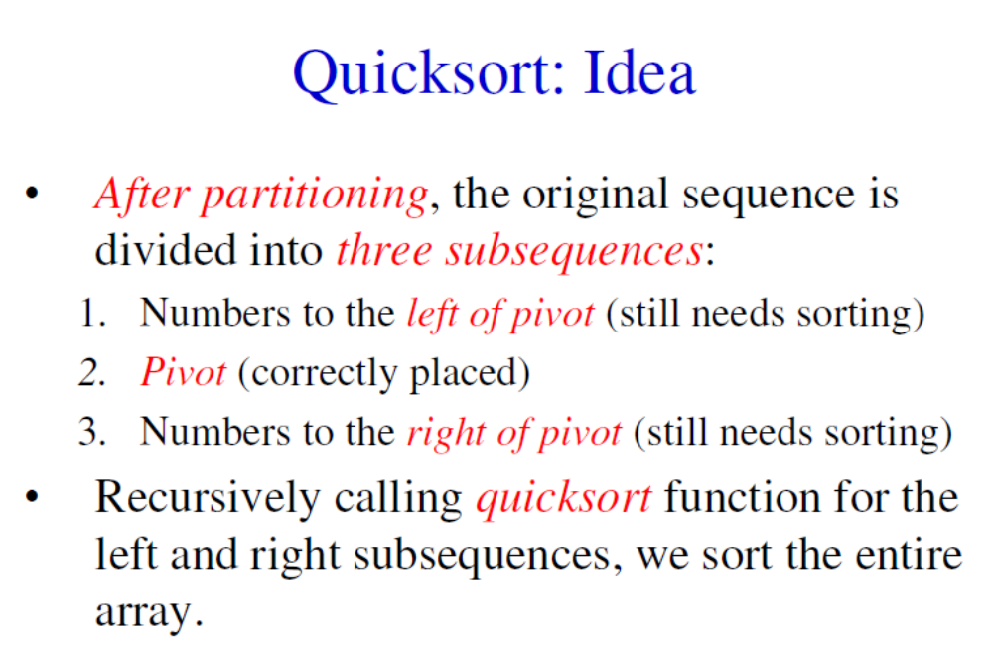

Algoritma adımları şu şekilde özetlenebilir:
- Diziden herhangi bir elemanı pivot eleman olarak seçer.
- Diziyi, pivot elemandan küçük olan bütün elemanlar pivot elemanın önüne, pivot elemandan büyük olan bütün elemanlar pivot elemanın arkasına gelecek biçimde düzenler.
- Quicksort algoritması recursive çağrılarak, oluşan küçük diziler tekrar sıralanır.
- Algoritma eleman sayısı sıfır olan bir alt diziye ulaşana kadar bu işlem devam eder.
- Eleman sayısı sıfır olan bir alt diziye ulaşıldığında algoritma bu dizinin sıralanmış olduğunu varsayar ve sıralama işlemi tamamlanmış olur.

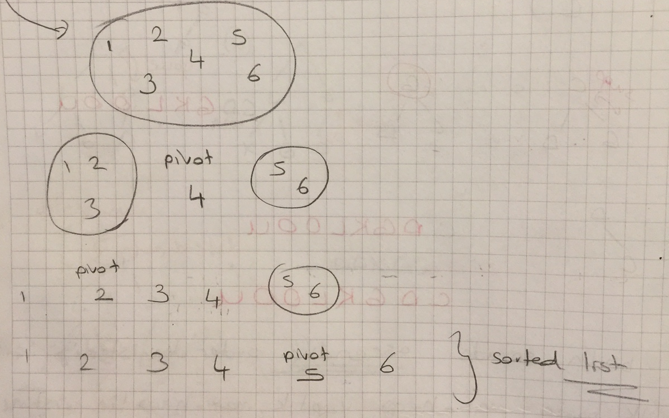

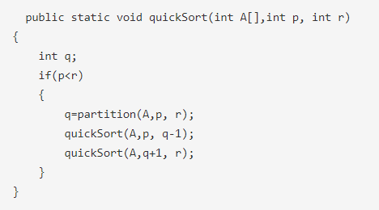

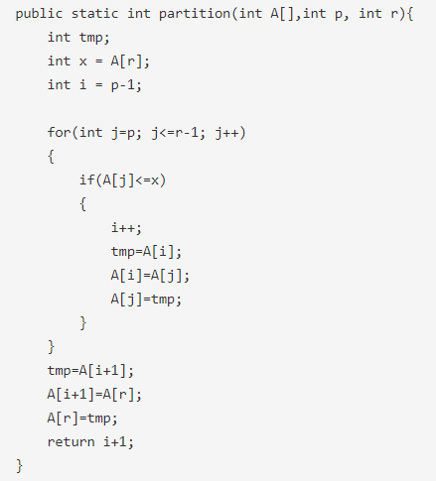
GOODLUCK

q=partition(A,p, r);
quickSort(A,p, q-1);
quickSort(A,q+1, r);

Pivot:D
C Pivot(=D) GOOLUK
quicksort (“GOOLUK”);

Pivot:O
GOKL (Pivot=O) U
quicksort (“GOKL”);

Pivot:K
G (Pivot=K) LO
quicksort (“LO”);

Pivot:L
(Pivot=L) O

C D G K L O O U

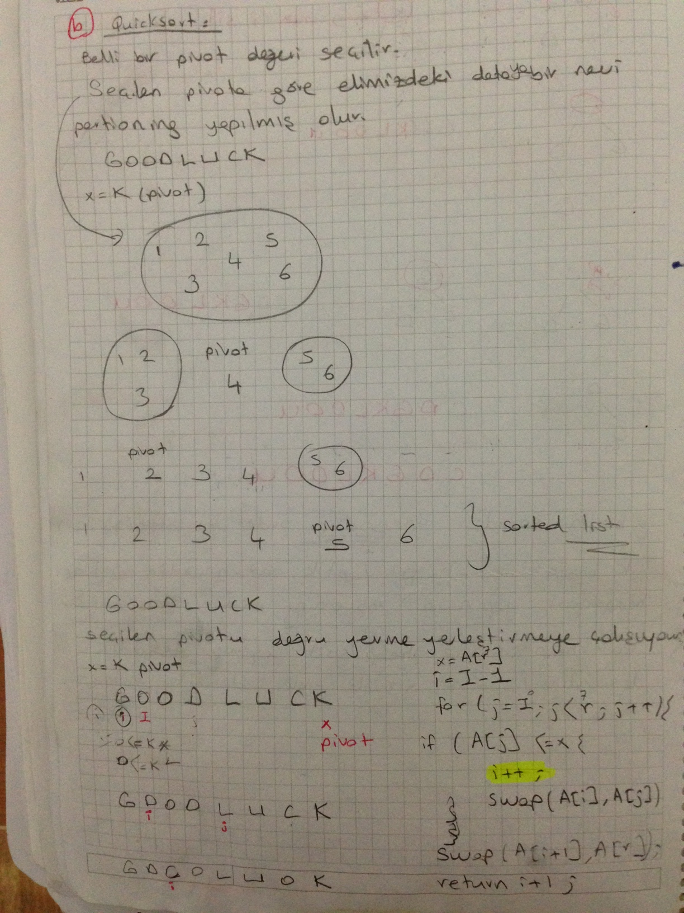

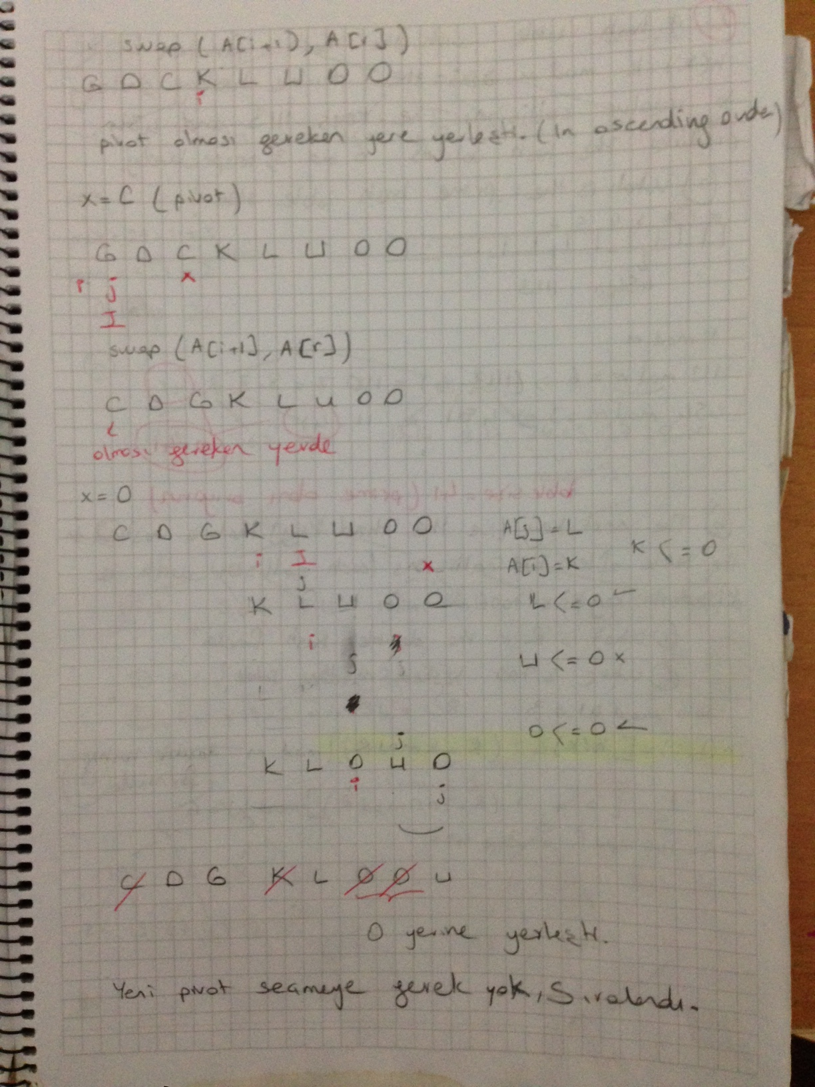

Q2. 2015 (15 pts)
Sort the following string of letters in descending order using heapsort?(For full credit show all steps)

UNIVERSITY

E
/ \
I N
/ \ / \
I U R S
/ \ /
V T Y

After heapsort

Y V U T S R N I I E

Q3. 2014 (10+15=25pts)
Consider the sequence of keys below:

10 19 13 a b 29 67 23 47 c d 53 37

- Determine the pivot by median-of-3 selection method and swap the last key (i.e., 37) with the pivot if necessary!

Median of 3 pivot selection: The first middle and last keys: 10, 67, 37. Sorted, the one in the middle is 37. Our first pivot is 37. Hence, we swap 37 with the last key. But, 37 itself is tha last key; hence no swaps necessary!

- Given that, for the first pivot, two swaps (before pivot is placed) are performed using Hoare’s method
  - Select a, b, c and d as prime numbers less than 100
  - (HOMEWORK)Show the resulting sequence where the two swaps are performed and the first pivot is placed at its correct position. Show the swaps!

Alternative solutions:
- a>37, b<37, c<37, d>37

An example solution:
a=41 b=31 c=17 and d=73

Original sequence:
10 19 13 41 31 29 67 23 47 17 73 53 37

After 37 is placed:
10 19 13 17 31 29 23 37 47 41 73 53 67

Q4. 2013(6+10= 16pts)
Here is an array which has just been partitioned by the first step of quicksort:
12 13 7 16 18 23 26 19 30

a) Which of these elements could be the pivot? If there are more than one possibility, show each possible element.
16, 18, 30

- (HOMEWORK) Considering your answer in “a”, perform the second step of quicksort using Hoare's partitioning algorithm we discussed in class!

Select :16 as pivot and apply quick Sort

